Year 4 Curriculum forecast - Autumn 1 2014
Literacy
In literacy, we will be using a contemporary story to explore the themes of suspicion and trust. We will identify how suspense is created in a story and incorporate this in our own writing. When reading aloud we will explore how to use our voices to create tension. Within our Non- fiction unit we will focus upon information texts presented in a variety of styles. We will plan and perform a presentation for a new gadget.
Numeracy
In numeracy, we will start this term revisiting number bonds to 100 and place value up to 4 digit numbers. We will add 2 digit numbers using partitioning and column addition and use counting up to subtract 2 and 3 digit numbers. We will focus on our 6 and 9 times tables with the aim to recall the multiplication and division facts fluently. Also we will write the time to the nearest minute using analogue and digital clocks.
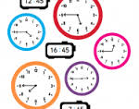
Religion
We will begin the year with the ‘The Bible’. We will learn that the Bible is a story of God’s love and concern for us and is a living book through which God speaks to us. We will learn that that if people go wrong God is always ready to forgive those who are sorry. We will share and read a range of stories in the Bible and discuss what they mean to us.
Science
We are beginning the year with the science topic ‘what’s that sound?’. We will be learning how sound reaches our ears and exploring how we can change the volume and pitch of instruments and everyday objects. We will finally investigate how sounds are created to make music!

Topic
In Geography our Geography unit ‘Where would you choose to build a city?’ we are going to locate some of Europe’s biggest cities in an atlas and identify their common features. We will look at a variety of cities including Manchester to explore the differences between cities and villages and even make our very own sky scrapper! Finally we will become travel agents and create a travel brochure for a European city.
Computing
This half term in computing we are going to become software developers! We will design and develop an educational computer game where will learn to detect and correct any errors in our own or other computer programmes.
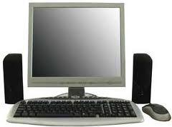
MFL
In our German unit ‘All about me’ we will be learning how to talk about ourselves and our families. We will focus on using the correct grammar and punctuation.

