St Anne’s RC Primary School
Moss Bank, Crumpsall, Manchester, M8 5AB
Tel: 0161 740 5995
Fax: 0161 795 0236
Headteacher : Mrs K Orrell (BEd Hons, NPQH)
School Web site www.stannescrumpsall.co.uk
Twitter-@Stannecrumpsall


Working, Learning, Caring and playing together in God’s love.

20.12.18
Dear Parents
As we finish for Christmas, the staff and I would like to share a Christmas Prayer with you.

A Christmas Prayer
Loving God, help us remember the birth of Jesus,
that we may share in the song of the angels,
the gladness of the shepherds,
and worship of the wise men.
Close the door of hate and open the door of love all over the world.
Let kindness come with every gift and good desires with every greeting.
Deliver us from evil by the blessing which Christ brings,
and teach us to be merry with clear hearts.
May the Christmas morning make us happy to be thy children,
and Christmas evening bring us to our beds with grateful thoughts,
forgiving and forgiven, for Jesus' sake. Amen.
-- Robert Louis Stevenson
During the last few weeks, we have shared some wonderful events with children, parents and family members. The music concert, nativities and the parish afternoon tea were highlights of the month and I would like to thank all the staff and children for their enthusiasm, hard work, and eagerness to perform- we truly have some very talented children and staff. Have a look at our twitter account to view some of these events.
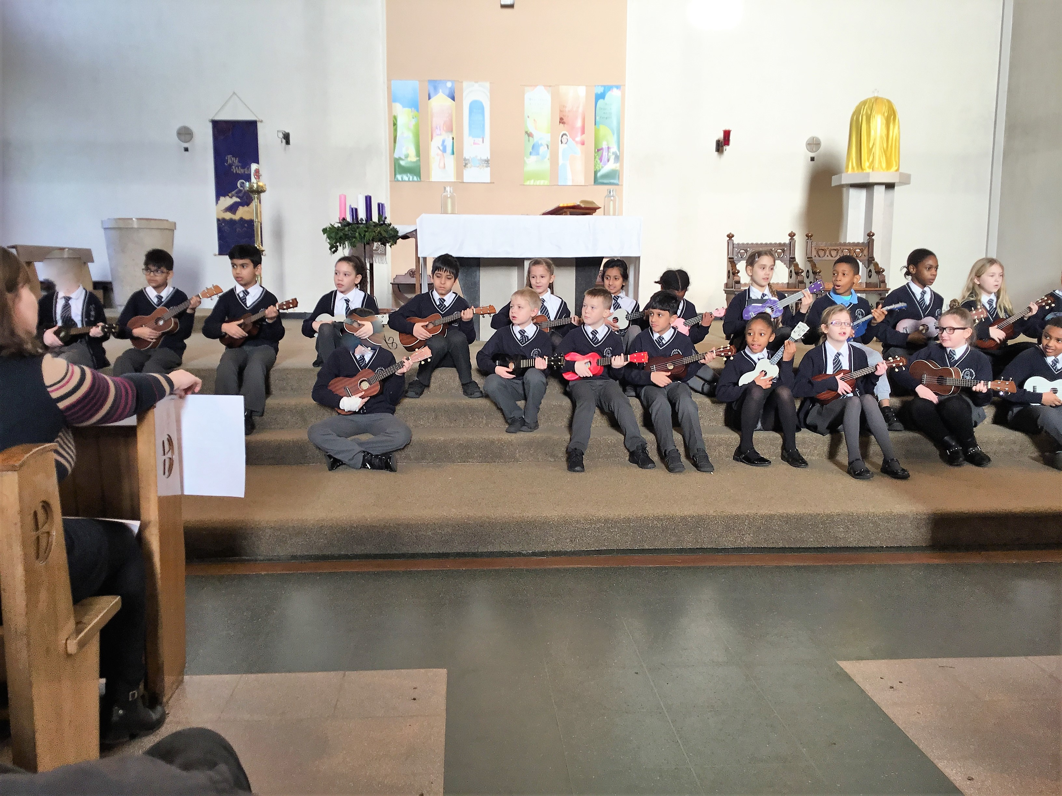 Year 4 L Music Concert.
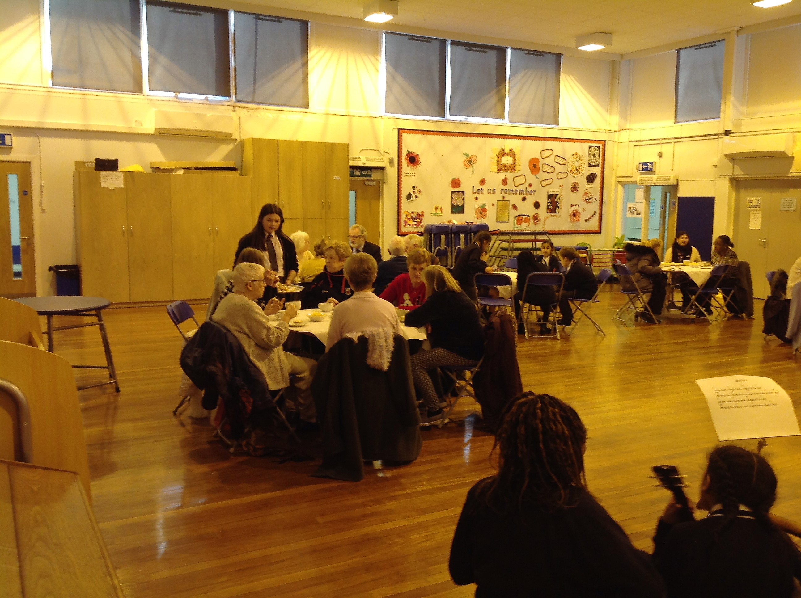 Over 60s Afternoon tea.
Fire Incident Outside School – Thank you for your support this morning in response to the car on fire on Crescent Ave. Our school emergency procedures, along with the swift response from the Fire Brigade and the help from the builders, who blocked off the road with their barriers, ensured that everyone was safe. I have checked with the owner of the car that they are ok which they are- although quite shook up.
Charity Fundraising – This month, we have concentrated on raising funds for St Anne’s Hospice. We have done this through collections at the Nativities, selling sweet cones (organised by the school chaplains and ambassadors with the support of Miss Irene and Ms Hamilton- Year 6 parent) and donations on Christmas Jumper Day. Hospices are extremely underfunded and work with families at the most difficult of times. St Anne’s Hospice needs to raise £20 000 every day to offer its wide range of services, so thank you for your generous donations to a very worthy cause.
Pantomime- well done to all our pupils who behaved exceptionally during the Pantomimes on Wednesday- they really enjoyed Jack and the Beanstalk and the audience participation was excellent.
Premises Update – Once again this term we have been busy updating the school premises. Work has included; new flooring, replacement lighting-both in school and at the side of school, new cupboards and shelves in the library and Y2S and of course the car park which should be finished early February. Once completed we are hoping to have a new KS1 play area developed!
Christmas Log Decorating – well done to Year 4, who spent some time on Monday making their own chocolate buttercream icing and decorating Christmas Logs. The children thoroughly enjoyed their baking sessions, the final logs were fantastic and made a lovely gift to take home. Thank you children for working so sensibly during your session and thank you to the staff who volunteered to help lead the sessions.
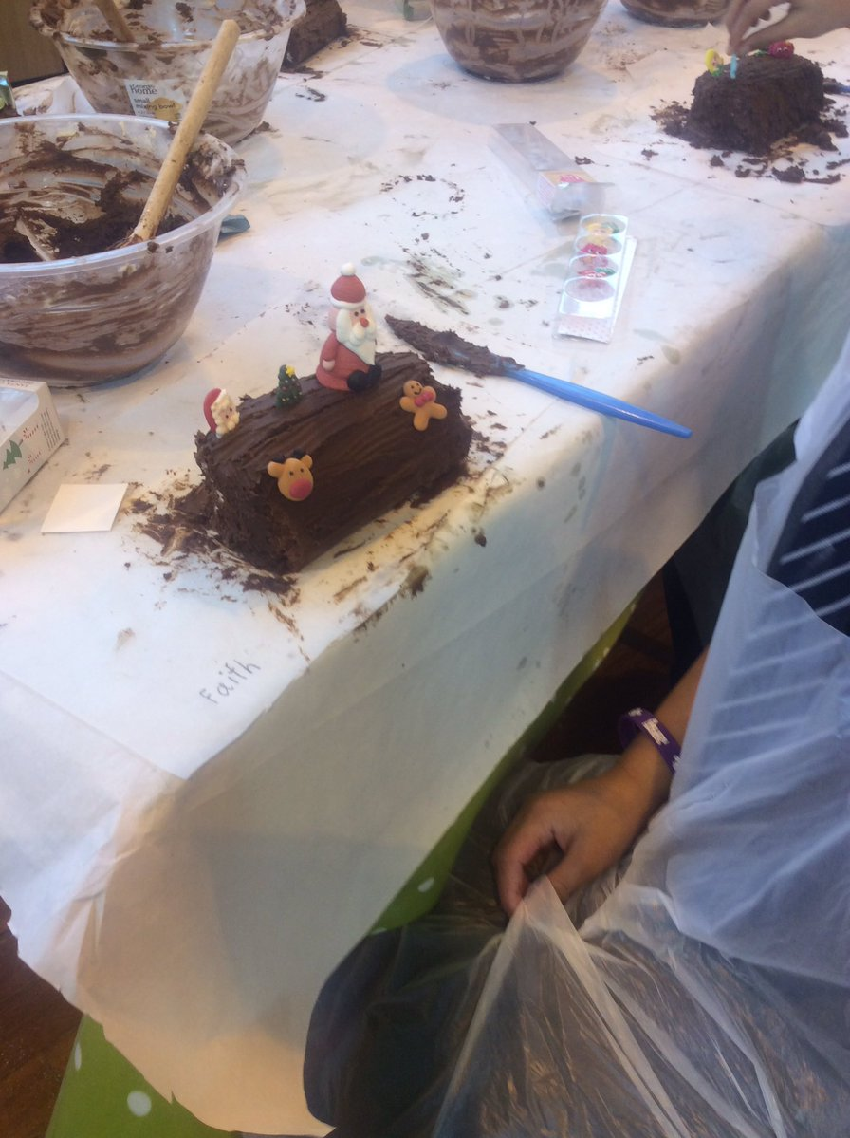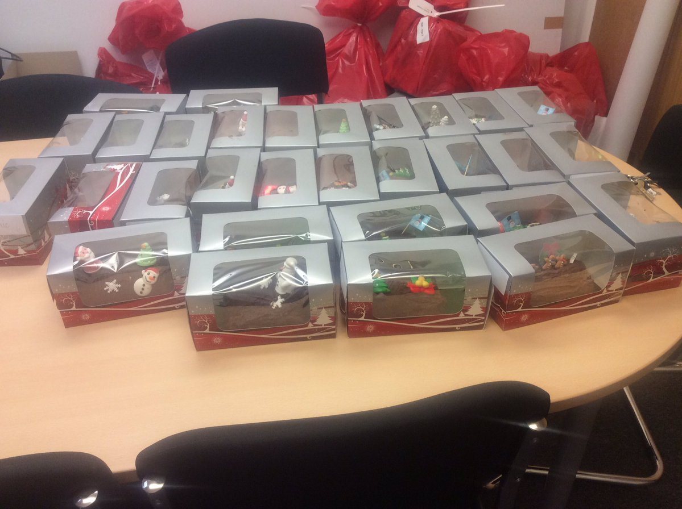

Trip to Royal Exchange- Earlier in the month, a group of 15 children visited the Royal Exchange to participate in a writing workshop. Yet again, we received wonderful feedback from school and theatre staff about the children’s engagement and excellent behaviour. In a time when the behaviour of young people is often portrayed negatively in the press I would like to congratulate all our children for their outstanding behaviour, as usual, this term.
Christmas Raffle- congratulations to everyone who won prizes in today’s Christmas raffle. Thank you to the office staff for collecting all the prizes and to our suppliers for their generous donations. The money raised will go into school fund and support the cost of parties, performances etc.
Final Day – we finish on Friday, tomorrow, at 1.00pm for the Christmas holidays and return on Monday 7th January at 8.55am.
During the morning, Father Christmas is hoping to visit all the children, who will be having their class parties. Children may wear non uniform for the last day.

As we come to the end of 2018, we would like to wish you all a peaceful and blessed Christmas and happiness and good health in 2019.
God Bless
Mrs Orrell and staff.



