Science Autumn Term
Newsletter – 2014
Issue 1

What being happening in the world of
Science at St Anne’s?
Floor books
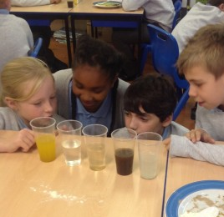
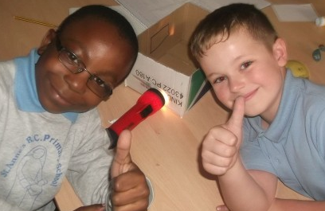
We have introduced a new way of recording in Science, we are trialling floor books. Floor books mean that we work as a group to record our findings and we can focus more on the doing of Science and less on the writing.

What the children have said: ‘We love working together as a team to solve problems’. ‘We get to do more fun Science’ ‘We can help each other out if we get stuck’
Science Ambassadors
At the beginning of the new term we had a real life scientist come into school and award two children from each class, who had been nominated by their teacher, the title of Science Ambassador. The children were awarded with white lab coats, a clip board and a pen and they have a very special role in science lessons and across school. They will help Mrs Clegg make important decisions regarding the Science curriculum at St Anne’s and come up with new ways to better Science for our school.

Science Club
Science club has run for 6 weeks for 21 children. We had a real life forensic scientist come and teach us about forensics: fingerprinting, crime scenes, different types of evidence. We had lots of fun! We then had a scientist who works at the brain imagery department at the hospital come and help us understand how the brain works through fun games. It was very interesting!
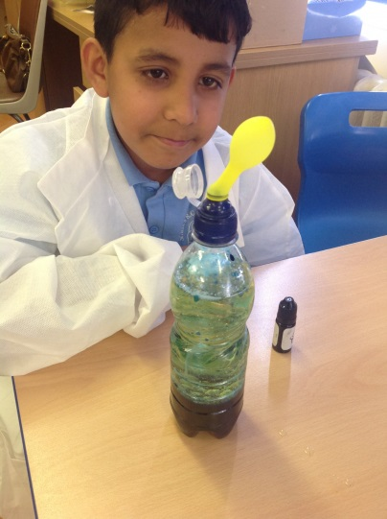
We have had that many children wanting to be part of the Science club we have extended it until February, so everyone, who wants to, will get a chance to attend. (Possible club after February half term too, we will keep you informed)
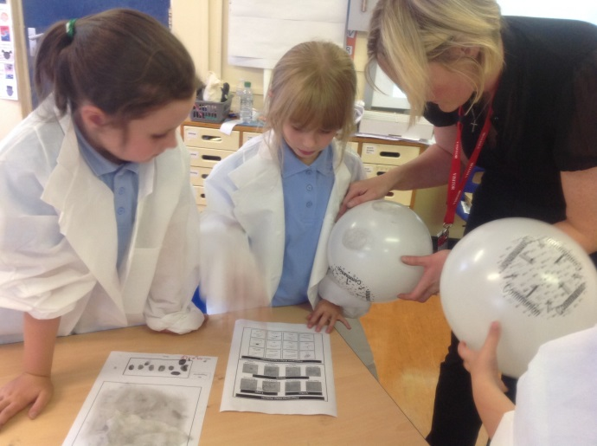
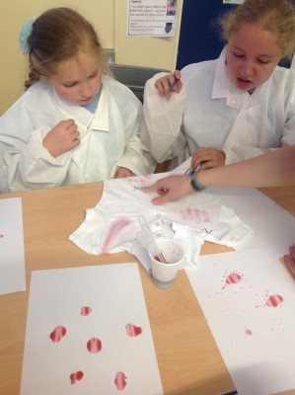
Upcoming events:
- Habitats and Animals (Blackpool Zoo Trip) 7.11.14
- Nesta’s Ark (Animals and Minibeasts come to school for Nursery and Reception 7.11.14
- Science Club – group 2 (Wednesday evenings afterschool 3-4pm Year 6 classroom)
- Staff Inset (Changes to the science curriculum/making science hands on) 3.11.12
- Gifted and Talented Challenge Year 5 and 6 (details to be confirmed)
- Science Showcase Extravaganza (Display of whole school science unit – animals) December, date to be confirmed.

Many Thanks
Science Ambassadors and Mrs Clegg (Science Coordinator)

